1
Szorzótábla
1 | 2 | 3 | 4 | 5
0 . 1 = 0 | 0 . 2 = 0 | 0 . 3 = 0 | 0 . 4 = 0 | 0 . 5 = 0
1 . 1 = 1 | 1 . 2 = 2 | 1 . 3 = 3 | 1 . 4 = 4 | 1 . 5 = 5
2 . 1 = 2 | 2 . 2 = 4 | 2 . 3 = 6 | 2 . 4 = 8 | 2 . 5 = 10
3 . 1 = 3 | 3 . 2 = 6 | 3 . 3 = 9 | 3 . 4 = 12 | 3 . 5 = 15
4 . 1 = 4 | 4 . 2 = 8 | 4 . 3 = 12 | 4 . 4 = 16 | 4 . 5 = 20
5 . 1 = 5 | 5. 2 = 10 | 5 . 3 = 15 | 5 . 4 = 20 | 5 . 5 = 25
6 . 1 = 6 | 6 . 2 = 12 | 6 . 3 = 18 | 6 . 4 = 24 | 6 . 5 = 30
7 . 1 = 7 | 7 . 2 = 14 | 7 . 3 = 21 | 7 . 4 = 28 | 7 . 5 = 35
8 . 1 = 8 | 8 . 2 = 16 | 8 . 3 = 24 | 8 . 4 = 32 | 8 . 5 = 40
9 . 1 = 9 | 9 . 2 = 18 | 9 . 3 = 27 | 9 . 4 = 36 | 9 . 5 = 45
10 .1 = 10 | 10 .2 = 20 | 10 .3 = 30 | 10 .4 = 40 | 10 .5 = 50
6 | 7 | 8 | 9 | 10
0 . 6 = 0 | 0 . 7 = 0 | 0 . 8 = 0 | 0 . 9 = 0 | 0 . 10 = 0
1 . 6 = 6 | 1 . 7 = 7 | 1 . 8 = 8 | 1 . 9 = 9 | 1 . 10 = 10
2 . 6 = 12 | 2 . 7 = 14 | 2 . 8 = 16 | 2 . 9 = 18 | 2 . 10 = 20
3 . 6 = 18 | 3 . 7 = 21 | 3 . 8 = 24 | 3 . 9 = 27 | 3 . 10 = 30
4 . 6 = 24 | 4 . 7 = 28 | 4 . 8 = 32 | 4 . 9 = 36 | 4 . 10 = 40
5 . 6 = 30 | 5 . 7 = 35 | 5 . 8 = 40 | 5 . 9 = 45 | 5 . 10 = 50
6 . 6 = 36 | 6 . 7 = 42 | 6 . 8 = 48 | 6 . 9 = 54 | 6 . 10 = 60
7 . 6 = 42 | 7 . 7 = 49 | 7 . 8 = 56 | 7 . 9 = 63 | 7 . 10 = 70
8 . 6 = 48 | 8 . 7 = 56 | 8 . 8 = 64 | 8 . 9 = 72 | 8 . 10 = 80
9 . 6 = 54 | 9 . 7 = 63 | 9 . 8 = 72 | 9 . 9 = 81 | 9 . 10 = 90
10 .6 = 60 | 10 .7 = 70 | 10 .8 = 80 | 10 .9 = 90 | 10. 10 = 100

Úgy tanuld, mint a verset! Többször le is írhatod!
2 Ha nincs színesed csak számold ki a példákat!
9-es szorzótábla
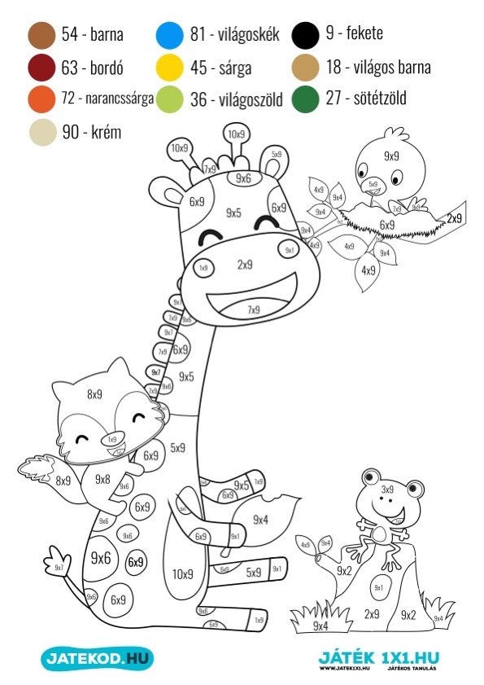

3
Gyakorlás
3 . 8 = _____ 9 . 4 = _____ 7 . 2 = _____ 6 . 5 = ______
5 . 3 = _____ 7 . 3 = _____ 5 . 9 = _____ 9 . 4 = ______
6 . 8 = _____ 4 . 5 = _____ 8 . 6 = _____ 3 . 4 = ______

32 : 8 = 9 . = 27 7 . = 35 . 5 = 45
63 . = 7 3 . = 15 27 : = 3 16 : = 4
9 . = 82 . 7 = 21 18 : 2 = : 10 = 8
64 : = 8 6 . = 30 45 : = 9 7 . = 28
. 8 :6 . 4 :2 .8 -4 :10
3

:2 .5 +5 :8 . 4 :10 .6
144

Az eredmények közül karikázd be a 8 többszöröseit!
4 . 6 = _____ 7 . 2 = _____ 16 + 16 = _____ 6 . 6 = ______
18 + 22 = ____ 4 . 5 = _____ 71 - 7 = _____ 9 . 4 = ______

Melyik az a szám? Ször több = szorzás ször kevesebb = Osztás
7-től 5-ször több ______ 15-től 5-ször kevesebb ______
25-től 5-ször kevesebb ______ 8-tól 5-ször több ______

3 . 8 = ______ 4 . 3 = ______ 6 . 9 = _____ 3 . 15 = _____ 5 . 120 =

6 . 5 = ______ 3 . 7 = ______ 7 . 13 = _____ 6 . 34 = _____ 4 . 25 =

4 Rajzold át az ábrákat – pontosan!
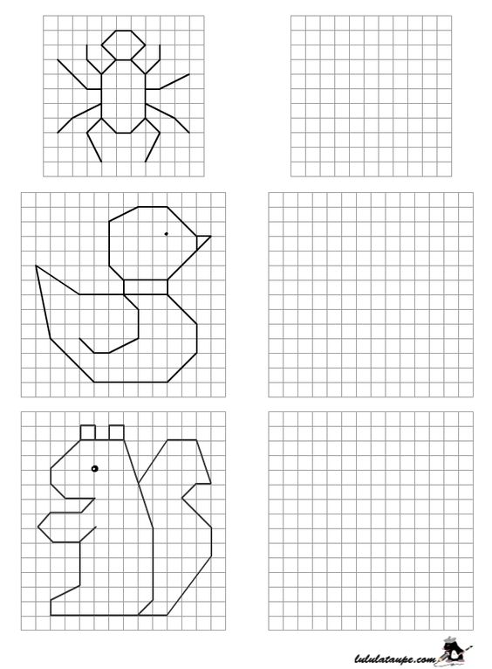

5 Szorzás, osztás
7 . 2 = 8 . 5 = 6 . 4 = 10 : 5 = 56 : 7 = 3 : 3 =
6 . 3 = 7 . 4 = 8 . 3 = 42 : 7 = 63 : 9 = 40 : 5 =
7 . 8 = 4 . 10 = 9 . 1 = 15 : 3 = 36 : 6 = 18 : 2 =
6 . 5 = 7 . 8 = 5 . 7 = 36 : 4 = 20 : 2 = 25 : 5 =
5 . 0 = 6 . 6 = 4 . 9 = 15 : 5 = 27 : 3 = 24 : 6 =
7 . 1 = 9 . 5 = 7 . 3 = 24 : 8 = 5 : 5 = 10 : 5 =
4 . 8 = 5 . 1 = 6 . 2 = 72 : 8 = 40 : 8 = 42 : 6 =
5 . 2 = 6 . 0 = 8 . 4 = 54 : 6 = 40 : 4 = 90 : 10 =
7 . 5 = 8 . 2 = 5 . 3 = 10 : 2 = 6 : 3 = 36 : 4 =
9 . 2 = 7 . 6 = 8 . 5 = 24 : 4 = 63 : 7 = 24 : 3 =
5 . 4 = 6 . 5 = 9 . 3 = 18 : 3 = 21 : 3 = 18 : 6 =
6 . 6 = 7 . 9 = 5 . 2 = 20 : 10 = 12 : 6 = 27 : 9 =
9 . 4 = 6 . 8 = 10 . 3 = 28 : 7 = 9 : 9 = 16 : 4 =
8 . 6 = 10 . 2 = 3 . 7 = 16 : 8 = 80 : 10 = 45 : 9 =
2 . 2 = 9 . 6 = 4 . 2 = 54 : 9 = 20 : 4 = 64 : 8 =
8 . 9 = 7 . 10 = 5 . 5 = 8 : 8 = 10 : 10 = 12 : 4 =
3 . 5 = 9 . 8 = 10 . 7 = 49 : 7 = 12 : 3 = 80 : 8 = 9 . 9 = 10 . 6 = 1 . 4 = 81 : 9 = 50 : 10 = 9 : 3 =
3 . 2 = 5 . 9 = 3 . 10 = 72 : 9 = 30 : 5 = 28 : 4 =
3 . 3 = 6 . 9 = 2 . 9 = 21 : 3 = 36 : 9 = 45 : 5 =
9 . 10 = 2 . 5 = 3 . 9 = 35 : 7 = 8 : 4 = 60 : 10 =
6
9 . 7 = 2 . 3 = 4 . 7 = 40 : 10 = 18 : 9 = 6 : 2 =
10 . 4 = 3 . 8 = 6 . 1 = 56 : 8 = 14 : 7 = 32 : 8 =
5 . 8 = 10 . 9 = 4 . 5 = 50 : 5 = 6 : 1 = 70 : 10 =
6 . 7 = 4 . 4 = 2 . 8 = 48 : 6 = 32 : 4 = 48 : 8 =
8 . 8 = 3 . 6 = 1 . 9 = 90 : 9 = 20 : 5 = 5 : 5 =
4 . 6 = 6 . 10 = 2 . 7 = 35 : 5 = 16 : 2 = 30 : 6 =
10 . 10 = 3 . 1 = 4 . 3 = 7 : 7 = 30 : 3 = 100 : 10 =
5 . 6 = 3 . 4 = 8 . 7 = 15 : 5 = 6 : 6 = 4 : 2 =
1 . 8 = 2 . 6 = 2 . 4 = 70 : 7 = 12 : 2 = 60 : 6 =
4 . 9 = 5 . 4 = 8 . 5 = 8 : 2 = 2 : 2 = 3 : 1 =
7 . 7 = 1 . 2 = 6 . 4 = 5 : 1 = 24 : 6 = 14 : 2 =
5 . 10 = 9 . 4 = 3 . 5 = 30 : 3 = 20 : 4 = 18 : 3 =
8 . 7 = 4 . 7 = 9 . 3 = 24 : 4 = 27 : 3 = 81 : 9 =
7 . 4 = 9 . 0 = 5 . 5 = 36 : 6 = 15 : 5 = 32 : 4 =
6 . 8 = 5 . 9 = 6 . 7 = 63 : 9 = 4 : 4 = 27 : 3 =

Számítsd ki!
3 . 5 + 7 . 8 = _________________ 6 . 4 + 2 . 8 = _________________
9 . 4 + 6 . 2 = _________________ 8 . 9 + 4 . 3 = _________________ 7 . 3 + 9 . 8 = _________________ 9 . 5 + 7 . 2 = _________________ 6 . 6 + 4 . 3 = _________________ 4 . 8 + 3 . 5 = _________________ 7 . 5 + 2 . 9 = _________________ 9 . 4 + 6 . 8 = _________________ 5 . 6 + 7 . 8 = _________________ 3 . 8 + 7 . 4 = _________________

