Szorzótábla
1 | 2 | 3 | 4 | 5
0 . 1 = 0 | 0 . 2 = 0 | 0 . 3 = 0 | 0 . 4 = 0 | 0 . 5 = 0
1 . 1 = 1 | 1 . 2 = 2 | 1 . 3 = 3 | 1 . 4 = 4 | 1 . 5 = 5
2 . 1 = 2 | 2 . 2 = 4 | 2 . 3 = 6 | 2 . 4 = 8 | 2 . 5 = 10
3 . 1 = 3 | 3 . 2 = 6 | 3 . 3 = 9 | 3 . 4 = 12 | 3 . 5 = 15
4 . 1 = 4 | 4 . 2 = 8 | 4 . 3 = 12 | 4 . 4 = 16 | 4 . 5 = 20
5 . 1 = 5 | 5. 2 = 10 | 5 . 3 = 15 | 5 . 4 = 20 | 5 . 5 = 25
6 . 1 = 6 | 6 . 2 = 12 | 6 . 3 = 18 | 6 . 4 = 24 | 6 . 5 = 30
7 . 1 = 7 | 7 . 2 = 14 | 7 . 3 = 21 | 7 . 4 = 28 | 7 . 5 = 35
8 . 1 = 8 | 8 . 2 = 16 | 8 . 3 = 24 | 8 . 4 = 32 | 8 . 5 = 40
9 . 1 = 9 | 9 . 2 = 18 | 9 . 3 = 27 | 9 . 4 = 36 | 9 . 5 = 45
10 .1 = 10 | 10 .2 = 20 | 10 .3 = 30 | 10 .4 = 40 | 10 .5 = 50
6 | 7 | 8 | 9 | 10
0 . 6 = 0 | 0 . 7 = 0 | 0 . 8 = 0 | 0 . 9 = 0 | 0 . 10 = 0
1 . 6 = 6 | 1 . 7 = 7 | 1 . 8 = 8 | 1 . 9 = 9 | 1 . 10 = 10
2 . 6 = 12 | 2 . 7 = 14 | 2 . 8 = 16 | 2 . 9 = 18 | 2 . 10 = 20
3 . 6 = 18 | 3 . 7 = 21 | 3 . 8 = 24 | 3 . 9 = 27 | 3 . 10 = 30
4 . 6 = 24 | 4 . 7 = 28 | 4 . 8 = 32 | 4 . 9 = 36 | 4 . 10 = 40
5 . 6 = 30 | 5 . 7 = 35 | 5 . 8 = 40 | 5 . 9 = 45 | 5 . 10 = 50
6 . 6 = 36 | 6 . 7 = 42 | 6 . 8 = 48 | 6 . 9 = 54 | 6 . 10 = 60
7 . 6 = 42 | 7 . 7 = 49 | 7 . 8 = 56 | 7 . 9 = 63 | 7 . 10 = 70
8 . 6 = 48 | 8 . 7 = 56 | 8 . 8 = 64 | 8 . 9 = 72 | 8 . 10 = 80
9 . 6 = 54 | 9 . 7 = 63 | 9 . 8 = 72 | 9 . 9 = 81 | 9 . 10 = 90
10 .6 = 60 | 10 .7 = 70 | 10 .8 = 80 | 10 .9 = 90 | 10. 10 = 100

Úgy tanuld, mint a verset! Többször le is írhatod!
2. Szorzás Így írd a példákat a részeredményekkel!
Minta: 8 . 4 = _32____ 4, 8 12, 16, 20, 24, 28, 32
7 . 3 = _______ ____________________________________________
9 . 2 = _______ ____________________________________________
6 . 4 = _______ ____________________________________________
8 . 8 = _______ ____________________________________________
4 . 5 = _______ ____________________________________________
7 . 6 = _______ ____________________________________________
2 . 9 = _______ ____________________________________________
5 . 7 = _______ ____________________________________________
9 . 5 = _______ ____________________________________________
6 . 3 = _______ ____________________________________________
4 . 7 = _______ ____________________________________________
6 . 6 = _______ ____________________________________________
3 . 3 = _______ ____________________________________________
7 . 4 = _______ ____________________________________________
5 . 8 = _______ ____________________________________________
9 . 3 = _______ ____________________________________________
10 . 6 = _______ ____________________________________________
8 . 6 = _______ ____________________________________________
3 . 5 = _______ ____________________________________________
6 . 2 = _______ ____________________________________________
7 . 5 = _______ ____________________________________________
3. Az ábrákat rajzold át pontosan az üres négyzethálóra!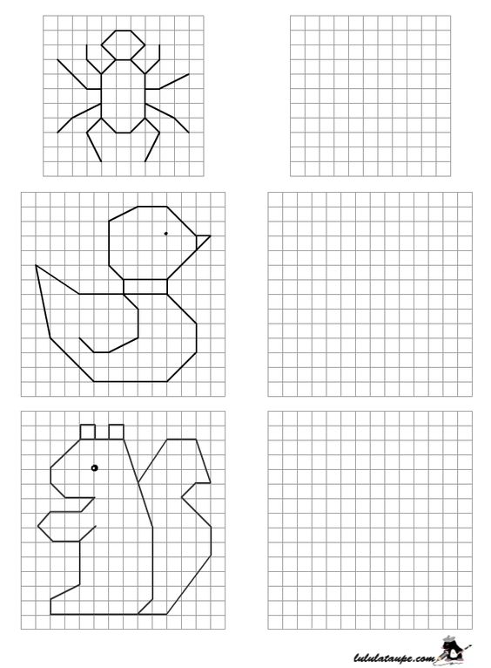
4. Osztás Így írd a minta szerint! (kis számokkal)
24 : 6 = ___4___ 24 – 6 = 18 – 6 = 12 – 6 = 6 – 6 = 0
32 : 4 = ______ ________________________________________________
10 : 2 = ______ ________________________________________________
30 : 5 = ______ ________________________________________________
12 : 3 = ______ ________________________________________________
36 : 6 = ______ ________________________________________________
18 : 2 = ______ ________________________________________________
21 : 3 = ______ ________________________________________________
40 : 5 = ______ ________________________________________________
25 : 5 = ______ ________________________________________________
16 : 4 = ______ ________________________________________________
24 : 8 = ______ ________________________________________________
42 : 7 = ______ ________________________________________________
20 : 4 = ______ ________________________________________________
30 : 5 = ______ ________________________________________________
60 : 10 = ______ _______________________________________________
15 : 3 = ______ ________________________________________________
28 : 7 = ______ ________________________________________________
32 : 8 = ______ ________________________________________________
24 : 3 = ______ ________________________________________________
10 : 2 = ______ ________________________________________________
18 : 2 = ______ ________________________________________________
5. Mennyi a következő ábrák fele? (Húzz át minden második ábrát!)
8-nak a fele: 4______________________
___________________________________
___________________________________
___________________________________
Mennyi a következő ábrák harmada? (Húzz át minden harmadik ábrát!)

_____ - nek a harmada _________________

_______________________________________

_______________________________________

Mennyi a következő ábrák negyede? (Húzz át minden negyedik ábrát!)

______-nak a negyede ____________________

________________________________________

________________________________________

_______________________________________
6. Négyjegyű számok
Ezres százas tízes egyes
2485 = 2000 + 400 + 80 + 5 = 2 . 1000 + 4 . 100 + 8 . 10 + 5 . 1
Bontsd fel a számokat ezresek százasok, tízesek egyesek összegére!
9361 = __________________________________________________________
7526 = __________________________________________________________
3140 = __________________________________________________________
2745 = __________________________________________________________
1607 = __________________________________________________________
8062 = __________________________________________________________
4903 = __________________________________________________________
6341 = __________________________________________________________
9001 = __________________________________________________________
5167 = __________________________________________________________

Állítsd vissza a felbontott számokat!
5000 + 800 +40 + 3 = __________ 2000 + 600 + 30 + 1 = __________
400 + 7000 +20 + 5 = __________ 300 + 9000 + 50 + 9 = __________
30 + 900 +2000 + 6 = __________ 6 + 800 + 4000 = __________
4 + 3000 +700 + 20 = __________ 7000 + 90 + 300 + 2 = __________
700 + 40 + 9000 + 3 = __________ 20 + 1000 + 4 = __________
600 + 8000 + 40 = __________ 50 + 3 + 9000 + 700 = __________
3000 + 10 + 7 = __________ 1000 + 400 + 80 + 6 = __________
5000 + 800 +40 + 3 = __________ 70 + 2000 + 2 + 500 = __________

